**Lab – 40: Add an app to Microsoft Intune and check it in Company Portal.**

**Objective:** The objective of this lab is –

* To add an app to Microsoft Intune and check it in Company Portal.

Once you've added an app to Intune, you can assign it to users and devices. In this lab, we are going to assign Office 365 ProPlus which contains Office Apps.

**Prerequisite:** EMS Enterprise Mobility + Security E5.

**Steps:**

1. Sign in to your Azure Portal, by using the link - **https://portal.azure.com/**. Enter your credentials and click Sign In.

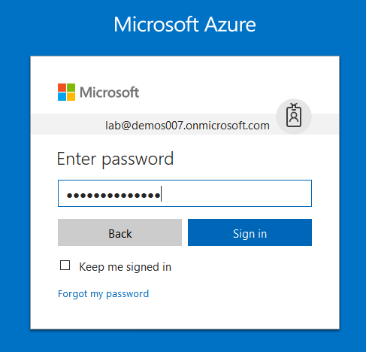

1. Microsoft Azure AD Dashboard will open.

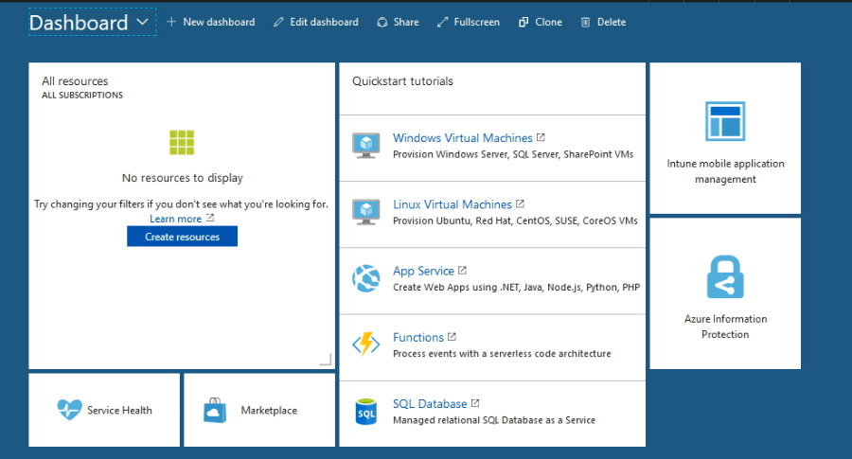

1. Open **Microsoft Intune** service from the left-hand side of the Azure portal.
2. Once you've opened the **Microsoft Intune** blade, select **Overview**.

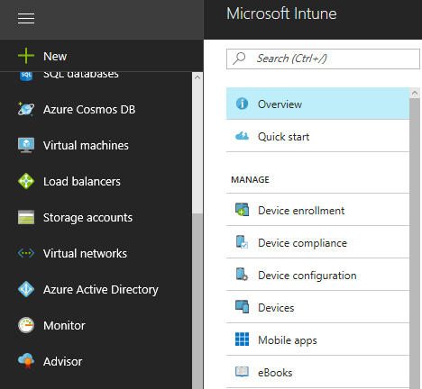

1. Then select **Add an App** from Quick tasks at the right hand side.

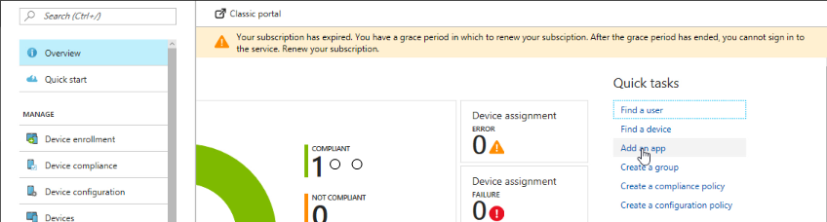

1. In the **Mobile apps** workload, choose **Manage** > **Apps**.

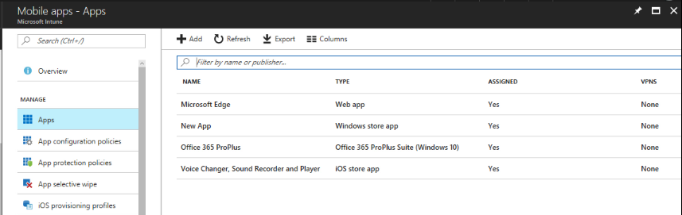

1. Above the list of apps, choose **Add**.

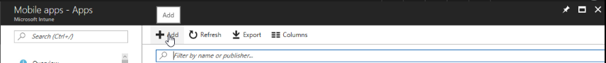

1. In the **Add App** blade choose the **App type**. Here select **Office 365 Suite** > **Windows 10**. Use this type to assign Office 365 ProPlus apps to Windows 10 devices with Intune. This suite of application will appear as one app in the apps list.

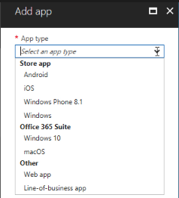

1. In the **Add App** blade, choose **Configure App Suite**.

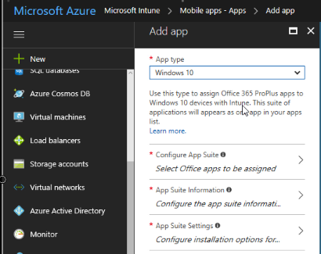

1. From here you can select or unselect office 365 apps that you want to install as part of the suite. After configuration click **Ok**.

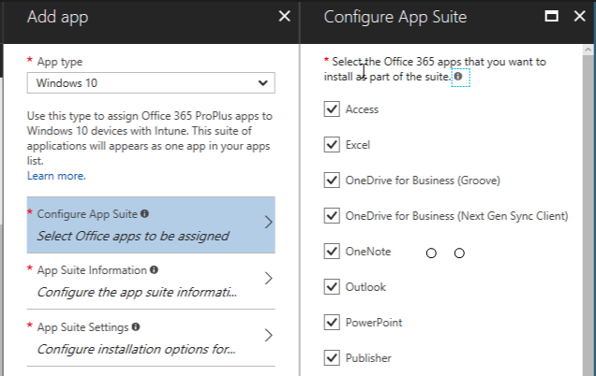

1. Then select **App information blade**, configure the information:

Suite Name: Enter the name of the suite name as it will be displayed in the company portal.

Suite Description: Enter a description for the suite. This will be displayed to end users in the company portal.

Publisher: Publisher name is already enabled.

Category (optional) - Select one or more of the built-in app categories, or a category you created. This will make it easier for users to find the app when they browse the company portal.

Display this as a featured app in the Company Portal - Display the app prominently on the main page of the company portal when users browse for apps. For this select **Yes**.

Information URL – Add information URL.

Privacy URL – Add privacy URL for your users.

Developer and Owner is already set. Add Notes (optional).

Logo is already created.

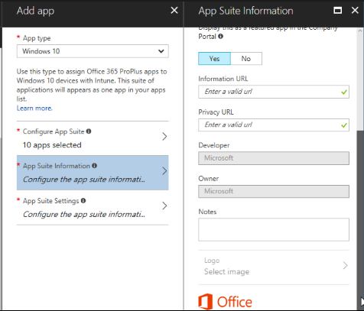

1. After configuring click **OK** in the App information blade.
2. Select **App Suite settings** from **Add app** blade. Configure Office version, update channel, properties and languages for your app. Then click **OK**.

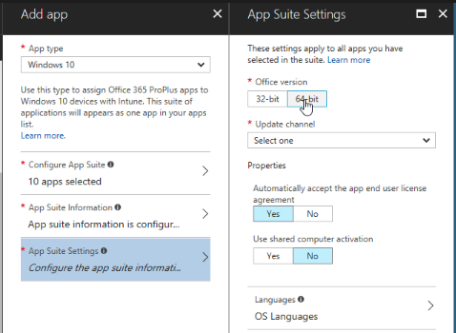

1. When you are done, on the Add App blade, choose **Add**. It will add application and also you will get the notification at the top right corner.

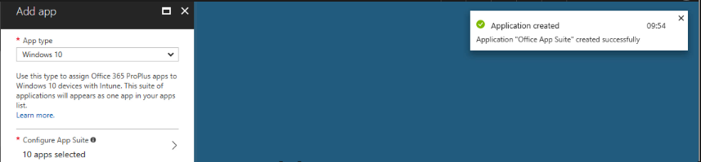

1. The app you have created will be displayed in the apps list where you can assign it to the groups you choose.
2. On the <app name> - **Overview** blade, choose **Manage** > **Assignments**.

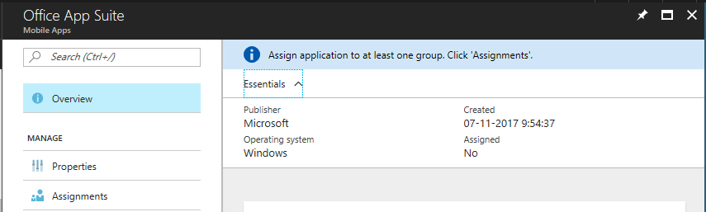

1. Choose **Select Groups** then.

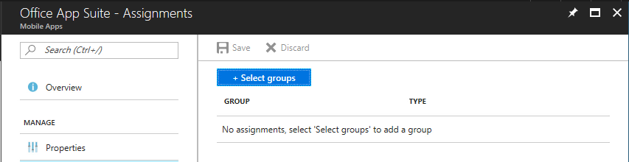

1. Then, on the **Select groups** blade, choose the Azure AD groups to which you want to assign the app and click **Select**.

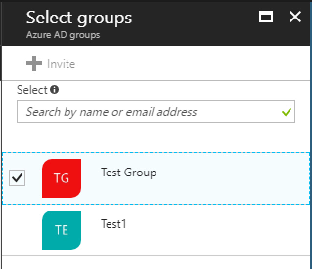

1. For each app you choose, choose an **assignment type** for the app from.

Available - Users install the app from the Company Portal app or website.

Not Applicable - The app is not installed or shown in the Company Portal.

Required - The app is installed on devices in the selected groups.

Uninstall - The app is uninstalled from devices in the selected groups.

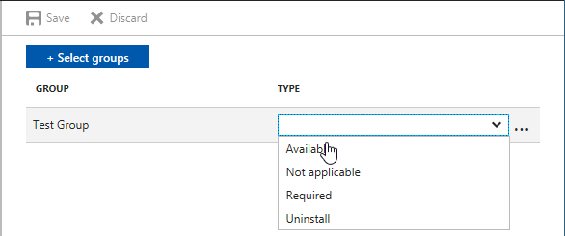

1. Once you are done, choose **Save**. The app is now assigned to the groups you selected.

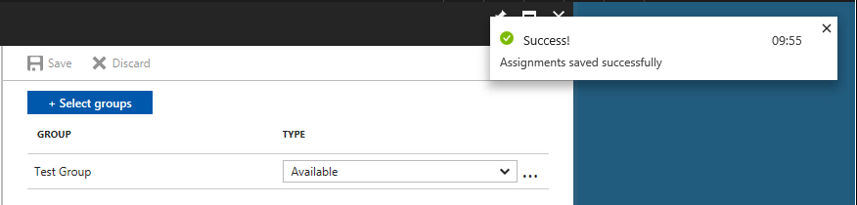

1. So, in this way you can add Office 365 Suite to Microsoft Intune & assign it to the group.
2. Now, open **Company Portal app**, and you can check whether the app is listed in the Apps List or not.
3. Here, you can see the app is not available to you.

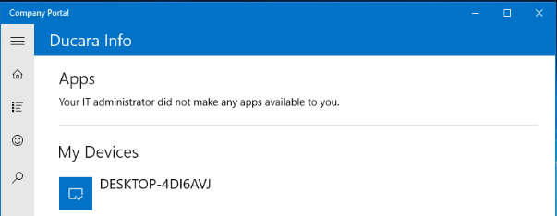

1. Go to the settings tab, and click Sync, to manually sync your device.

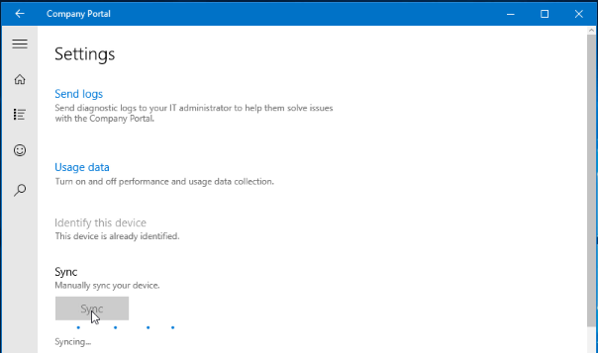

1. After that, you can go to Home or App list and there you can see the **Office 365 ProPlus** is now available to you.

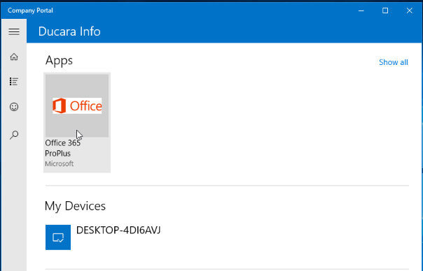

1. You can also go to the Apps List and check the available apps.
2. So, in this way you can add an app to Microsoft Intune and check it in Company Portal.